**BEAUTY OF KONKAN:TOURISM WEBSITE**

**A Project Report**

Submitted in partial fulfillment of the

Requirements for the award of the Degree of

# BACHELOR OF SCIENCE (INFORMATION TECHNOLOGY)

**By**

Mr. Vishal Shankar Parab

SIT3229

**Under the esteemed guidance of**

# Mr. Aditya Vardam

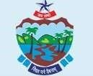

**DEPARTMENT OF INFORMATION TECHNOLOGY**

## SHRI PANCHAM KHEMRAJ MAHAVIDAYALAYA SAWANTWADI

***(Affiliated to University of Mumbai)***

**SAWANTWADI,416510**

**MAHARASHTRA**

**2023-2024**

## SHRI PANCHAM KHEMRAJ MAHAVIDAYALAYA SAWANTWADI

***(Affiliated to University of Mumbai)***

**SAWANTWADI-MAHARASHTRA-416510**

## DEPARTMENT OF INFORMATION TECHNOLOGY

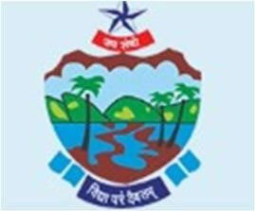

**CERTIFICATE**

This is to certify that the project entitled, " **BEAUTY OF KONKAN:TOURISM WEBSITE**", is bonafied work of **VISHAL SHANKAR PARAB** bearing Seat No:

**SIT3229** submitted in partial fulfillment of the requirements for the award of degree of

BACHELOR OF SCIENCE in INFORMATION TECHNOLOGY from University of

Mumbai.

**Internal Guide Coordinator**

**External Examiner**

**Date: College Seal**

# ABSTRACT

In a social media, where platforms cater to diverse interests and communities, there exists a noticeable gap for Dashavatar artists – a niche that is currently underserved. Dashavatar, with its rich cultural and artistic significance, deserves a dedicated space where artists and enthusiasts can connect, collaborate, and showcase their talents without the congestion often encountered on mainstream platforms.

By establishing a social media platform exclusively for Dashavatar artists, this initiative aims to address the challenges faced by artists in finding a suitable space to network and share their passion. It recognizes the need for a specialized community that can serve as a social media website for creativity, cultural preservation, and professional growth within the unique approach for Dashavatar Natyamandal.

# ACKNOWLEDGEMENT

Many people have helped me during my project and each of their contribution has been valuable. The timely completion of this project is mainly due to the interest and worth helping of Mr. Aditya Vardam their help will be remembered forever.

I would like to thank them to Guide me during my project work. I would like to thank all those who directly and indirectly helped in Completion of this Project.

# DECLARATION

I here by declare that the project entitled, “**BEAUTY OF KONKAN:TOURISM WEBSITE**” done at **Sawantwadi**, has not been in any case duplicated to submit to any other university for the award of any degree. To the best of my knowledge other than me, no one has submitted to any other university.

The project is done in partial fulfillment of the requirements for the award of degree of

**BACHELOR OF SCIENCE (INFORMATION TECHNOLOGY)** to be submitted

as final semester project as part of our curriculum.

**Name and Signature of the Student**

# TABLE OF CONTENTS

|  |  |  |
| --- | --- | --- |
| **1.** | **Chapter1: Introduction** | 1 |
| **1.1 Background** | 2 |
| **1.2 Objective** | 3 |
| **1.3 Purpose and Scope** | 4 |
| **1.3.1 Purpose** | 4 |
| **1.3.2 Scope** | 5 |
| **2.** | **Chapter 2: System Analysis** | 6 |
| **2.1 Existing Technologies** | 6 |
| **2.2 Proposed System** | 7 |
| **2.3 Requirement Analysis** | 8 |
| **2.4 Hardware Requirements** | 9 |
| **2.5 Software requirements** | 10 |
| **2.6 Justification of selection of Technology** | 11 |
| **3.** | **Chapter 3: System Design** | 16 |
| **3.1 Module Design** | 16 |
| **3.2 Data Dictionary** | 17 |
| **3.3 ER-Diagram** | 21 |
| **3.4 DFD/UML Diagrams** | 22 |
| **4.** | **Chapter 4: Implementation and Testing** | 29 |
| **4.1 Code** | 29 |
| **4.2 Testing Approach** | 30 |
| **4.2.1 Unit Testing** | 30 |
| **4.2.2 Integration Testing** | 30 |
| **4.3 Test Report** | 31 |
| **5.** | **Chapter 5: Result and Discussions** | 32 |
| **5.1 Screenshots** | 32 |
| **6.** | **Chapter 6: Conclusion and Future Work** | 41 |
| **6.1 Conclusion** | 41 |
| **6.2 Future Work** | 42 |
| **7.** | **Chapter 7: References** | 43 |

# Chapter 1 Introduction

The Konkan region, nestled along the western coastline of India, is renowned for its breathtaking natural beauty, pristine beaches, lush green landscapes, and rich cultural heritage. Stretching from the coastal states of Maharashtra, Goa, and Karnataka, Konkan has emerged as one of the most sought-after destinations for both domestic and international travelers. The region’s picturesque scenery, tranquil backwaters, diverse flora and fauna, and historical landmarks contribute to its growing popularity in the tourism sector.

This mini project, titled "The Beauty of Konkan Tourism", aims to explore the key attractions, natural beauty, cultural significance, and tourist experiences that make Konkan a unique travel destination. Through this project, we will examine the various tourism hotspots, such as the serene beaches of Alibaug, the historic forts of Sindhudurg, and the vibrant traditions of Goa. Additionally, this report provides insights into the region’s eco-tourism potential and how sustainable practices can enhance the tourism experience while preserving Konkan's fragile ecosystems.

This report is structured to highlight the geographical overview of Konkan, followed by an in-depth look at its tourist attractions, cultural festivals, local cuisine, and economic impact on the region. With the growing interest in coastal tourism and eco-friendly travel, the Konkan region holds immense potential for further development as a premier tourist destination.

## 1.1 Background

Welcome to Dashavatar social media website, a revolutionary social media platform designed to growing Dashavatar industries. we connect, share, and engage in the digital world. In a world where relationships and communities are increasingly influenced by online interactions, Dashavatar social media website aims to create a vibrant and inclusive space that goes beyond the conventional boundaries of social networkin

## 1.2 Objectives

The primary objective of this project is to design and develop a user-friendly and visually appealing website that promotes tourism in the Konkan region. The website will showcase the natural beauty, cultural heritage, and tourist attractions of Konkan, with the aim of providing comprehensive information to potential travelers. This includes:

1. **Highlighting Key Destinations**: Offering detailed descriptions of popular tourist spots, such as beaches, temples, historical sites, and scenic landscapes.
2. **Travel Guides and Tips**: Providing practical information for travelers, such as accommodation, transportation options, and recommended itineraries.
3. **Interactive Features**: Incorporating user-friendly features like maps, photo galleries, and testimonials to enhance user experience.
4. **Boosting Local Tourism**: Promoting local businesses, handicrafts, and cultural experiences, thereby supporting the local economy.
5. **Mobile Responsiveness**: Ensuring that the website is accessible on all devices, including desktops, tablets, and smartphones.
6. **Environmental Awareness**: Encouraging sustainable and eco-friendly tourism practices to preserve the natural beauty of the Konkan region for future generations.

.

## 1.3 PURPOSE AND SCOPE

### 1.3.1 Purpose

The purpose of this project is to develop a comprehensive website that showcases the beauty and tourism potential of the Konkan region. The primary objectives include:

* Promotion of Konkan Tourism: To highlight the scenic locations, cultural heritage, and attractions in the Konkan region, thereby promoting tourism and attracting visitors from across the world.
* User-Friendly Information Source: To provide a user-friendly platform where travelers can easily access detailed information on various tourist spots, accommodations, travel guides, and local cuisines in Konkan.
* Increased Awareness of Local Culture: To enhance awareness about the rich and diverse cultural traditions of the Konkan region, including festivals, crafts, and historical significance.
* Support for Local Economy: By promoting local attractions, the website aims to support local businesses such as hotels, restaurants, tour operators, and artisans, contributing to the economic growth of the region.
* Interactive Features: To incorporate interactive features such as feedback forms, itinerary planners, and contact information for tourism support to ensure a better user experience and engagement.
* Sustainable Tourism: To encourage responsible and sustainable tourism practices, focusing on eco-friendly travel options and preservation of natural resources.

### 1.3.2 Scope

The "Beauty of Konkan Tourism" website aims to provide a comprehensive platform for showcasing the unique attractions, natural beauty, and cultural richness of the Konkan region. The primary goal of the project is to promote tourism by offering valuable information to travelers, including details on tourist destinations, local cuisine, festivals, historical landmarks, and adventure activities. The website will serve as an easy-to-navigate guide for both domestic and international tourists interested in exploring the scenic coastal landscapes and hidden gems of Konkan.

# Chapter 2 System Analysis

## 2.1 Existing System

The existing system for the "Beauty of Konkan" tourism website offers a basic online presence for showcasing the scenic beauty and tourist attractions of the Konkan region. This system typically consists of static webpages that provide general information about popular tourist destinations, local culture, and important landmarks. However, the current setup lacks an interactive user interface, personalized recommendations, and real-time updates. The user experience is limited, with minimal content organization, and there is no integration of advanced features such as online bookings, interactive maps, or user-generated reviews. Furthermore, the system does not effectively engage users through multimedia content like videos or virtual tours, which can enhance the visual appeal of Konkan tourism. Consequently, the current system needs improvement in terms of both functionality and user engagement to meet modern tourism website standards.

## 2.2 Proposed System

* Promote konkan tourism
* Know our culture to everyone in the world
* Support for Local Economy
* Easy-to-understand user interface

## 2.3 Requirement Analysis

2.3.1 Specification Of Requirement:

Selecting technologies to develop any application is the first step to complete an application successfully. A study of resource availability that may affect the ability to achieve an acceptable system. This evaluation determines whether the technology needed for the proposed system is available or not. This system can be made in any language that supports a good user interface and easy database handling. Technical needs may include:

**2.4 Hardware Requirements**

1. RAM : 8GB

## 2.5 Software Requirements

**Software Requirements (Developer side):**

1. OPERATING SYSTEM: Windows 11.
2. FRONT END: Visual Studio Code , Html, CSS, Javascript.
3. BACK END: PHP, MYSQL.
4. BROWSER: Google Chrome/ Mozilla Firefox/Microsoft Edge.

**Software Requirements (Client Side):**

1. Browser: Google Chrome/Mozilla Firefox/ Microsoft Edge
2. Operating System: Windows 11

## 2.6 Justification of Selection of Technology

Selecting Technologies to develop any application is the very first step in order to complete an application successfully. A study of resource availability that may affect the ability to achieve an acceptable system. This evolution determines whether the technology needed for the purpose system is available or not. This system can be made in any language that supports a good interface user interface and easy database handling technical needs may include:

**Front-end language selection:**

Front-end means a language that is used for user interface and designing and coding.

Front-end should have the following qualities.

* It must have go system support.
* Platform independent.
* Easy to deploy and maintain.
* Front-end must support some popular Back-end SQL Server.

According to the above features, I selected HTML, CSS, and JavaScript as Front-end for developing my project.

**Back-end language selection:**

The Back-end refers to the server side of a web application or software, where data processing, storage, and logic take place. It's responsible for handling requests from the front end, interacting with databases, executing server-side logic, and sending responses back to the client.

The backend should have the following qualities:

* Easy to implement with front end.
* Easy to install.
* It should be scalable.
* Implement robust security.
* Effectively manage and store data.

According to the above-stated features I select PHP, and MYSQL database.

**PHP:**

PHP (Hypertext Preprocessor) is a widely-used open-source server-side scripting language designed primarily for web development. It is a powerful tool for creating dynamic and interactive web pages, allowing developers to generate HTML content in real-time based on user inputs or database interactions.

**MYSQL Database:**

MySQL is an open-source relational database management system (RDBMS) that uses structured query language (SQL) to manage and manipulate databases. It is widely used in web applications, particularly with PHP, and follows the client-server model.

A software process (Also known as software methodology) is a set of related activities that leads to the production of software. These activities may involve the development of the software from scratch, or modifying an existing system.

Here I am selecting the Waterfall model as a process model for developing my project.

## Waterfall model

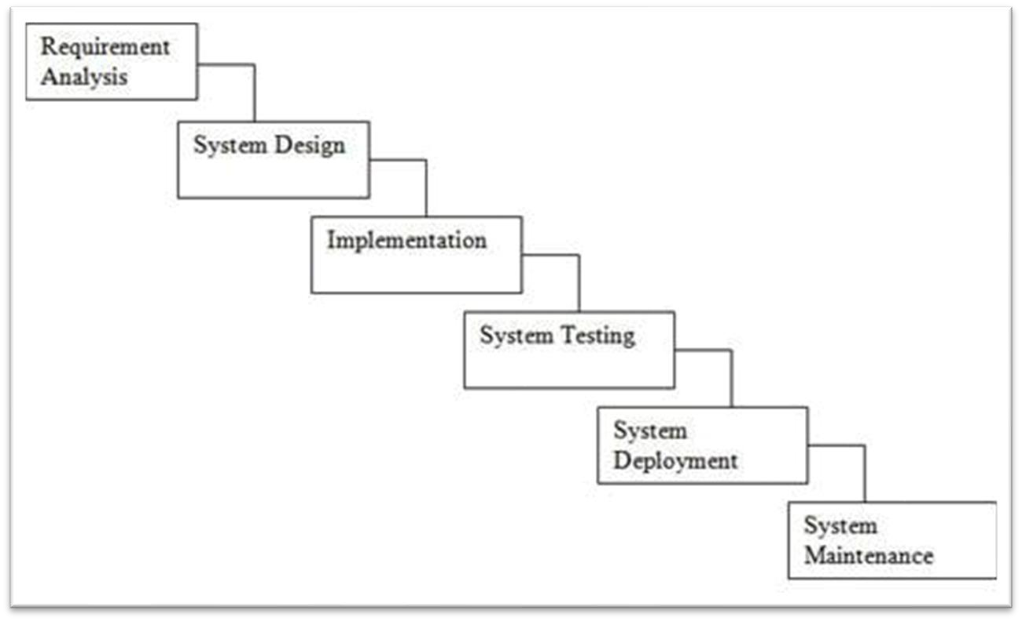

## Gantt Chart

|  |
| --- |
|  |

Actual

Planned

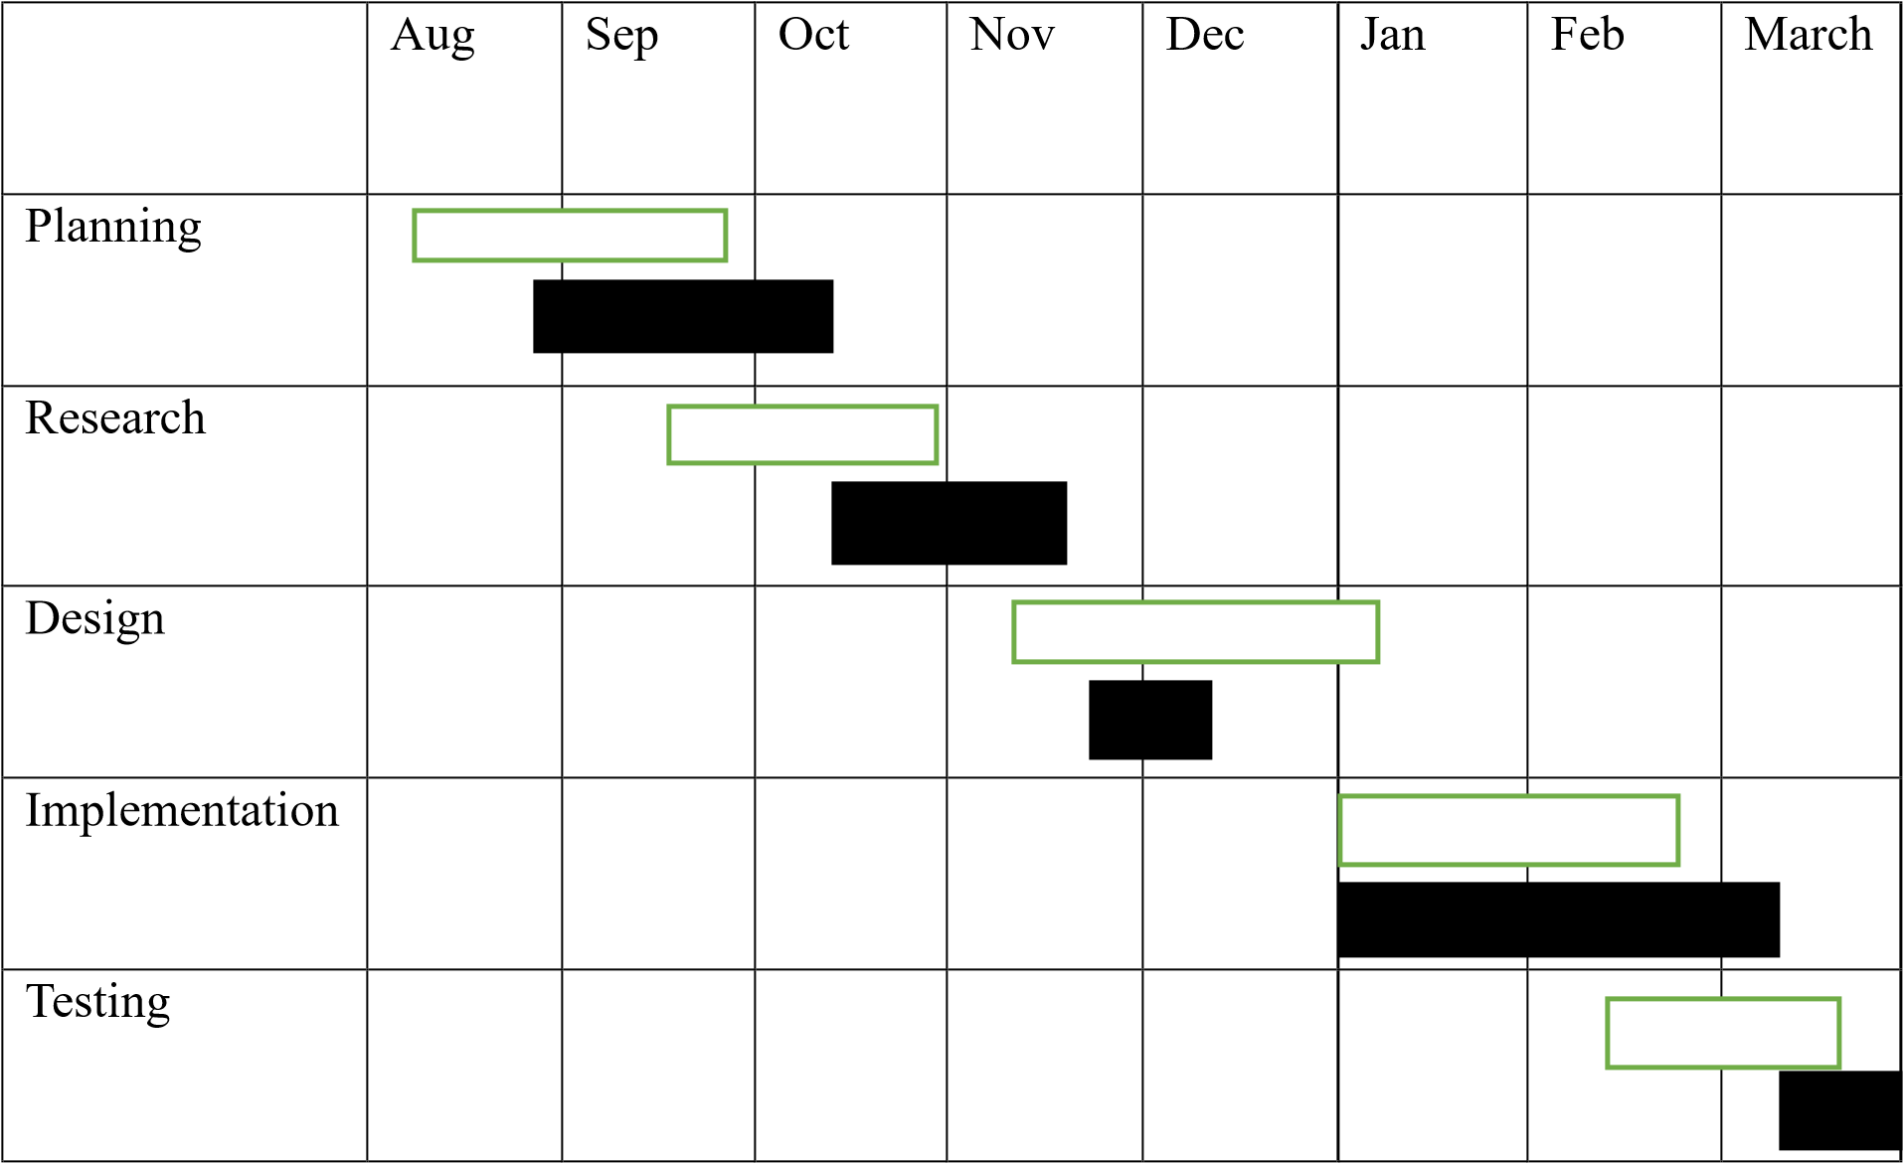

# Chapter 3 System Design

**3.1 Module Division:**

This Project Includes Modules such as:

**1.Authentication Module:**

1. User Registration: Enables user to create new accounts with page.
2. Viewer Registration: Enables to create new account
3. Login/Logout: Facilitates secure access to user accounts and allows for smooth logout procedures.

**2.Profile Module:**

1. User Profiles: Provides users with the ability to create and manage their pages, including personal details, interests, and a portfolio of Dashavatar artwork.
2. Viewing Profiles: Allows viewers to explore Dashavatar artist profiles, fostering connections and appreciation of diverse artistic styles.

**3.Content Discovery Module:**

1. Feed: A personalized feed for users, showcasing Dashavatar artworks, updates, and activities from artists they follow.
2. Search: Empowers users and viewers to discover Dashavatar pages, and relevant content using search functionalities.

**4.Engagement Module:**

1. Likes and Comments: Allows users and viewers to engage with Dashavatar artworks by expressing appreciation through likes and comments.
2. Shares: Facilitates the sharing of Dashavatar artworks on other social media platforms to expand the reach of the art.

**5.Connection Module:**

1. Follow/Unfollow: Allows users and viewers to follow their favorite Dashavatar artists and stay updated on their latest creations.

## 3.2 Data Dictionary

**Table Name: Post**

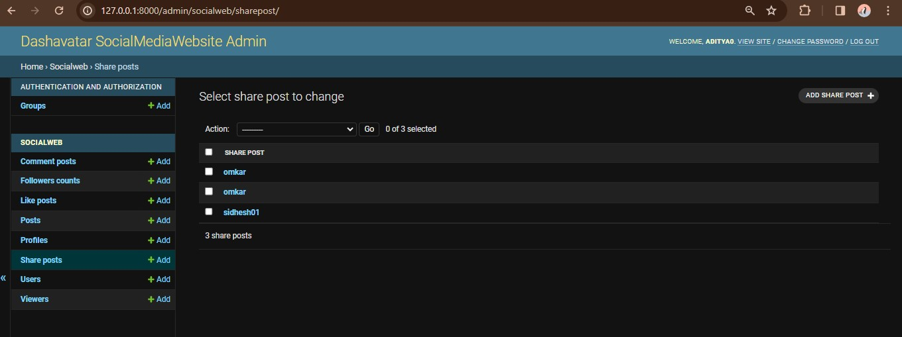

**Table Name: Comments**

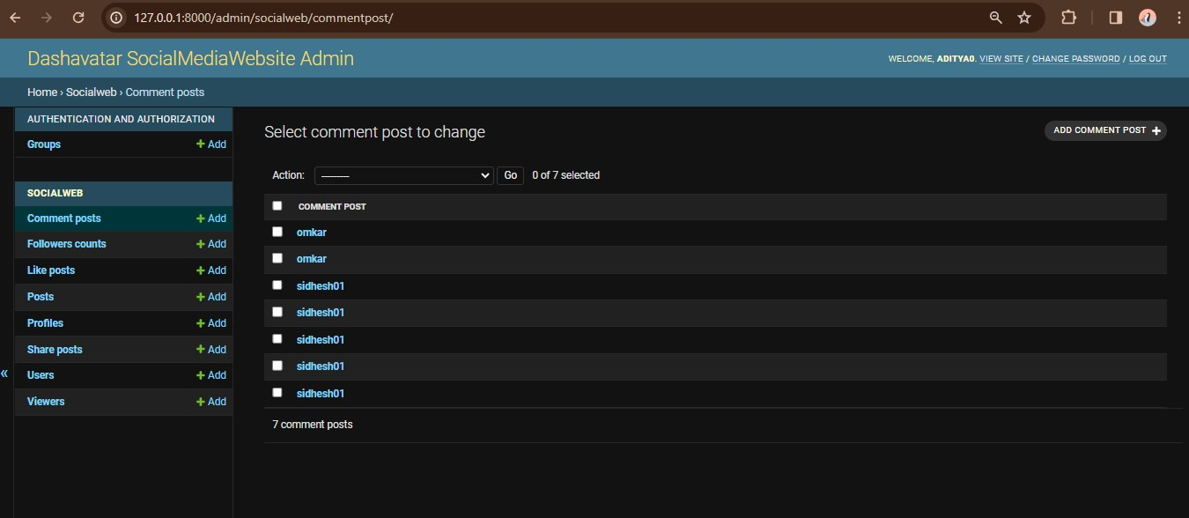

**Likes**

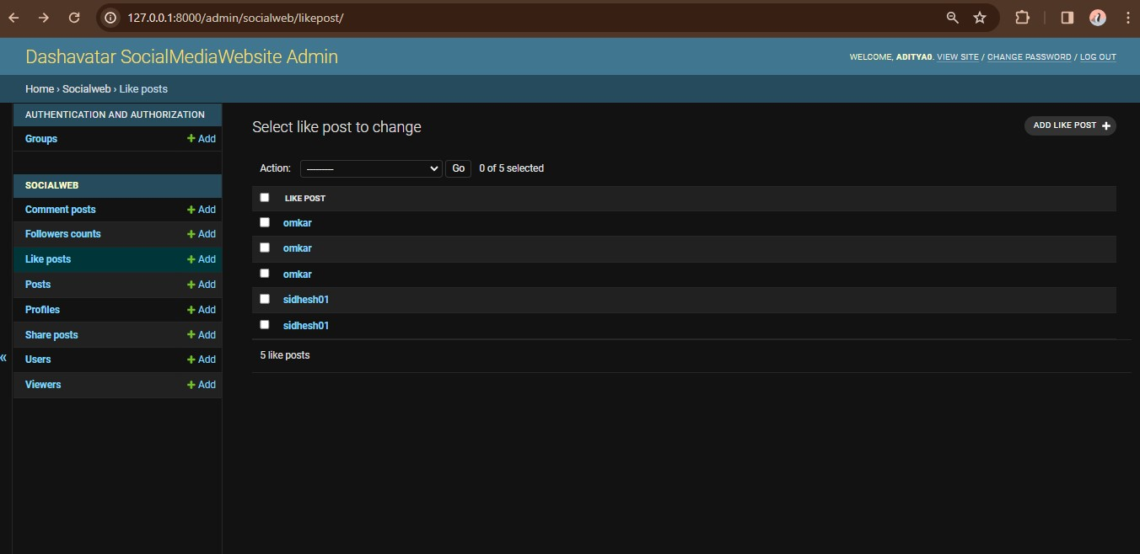

**Table Name: Viewers**

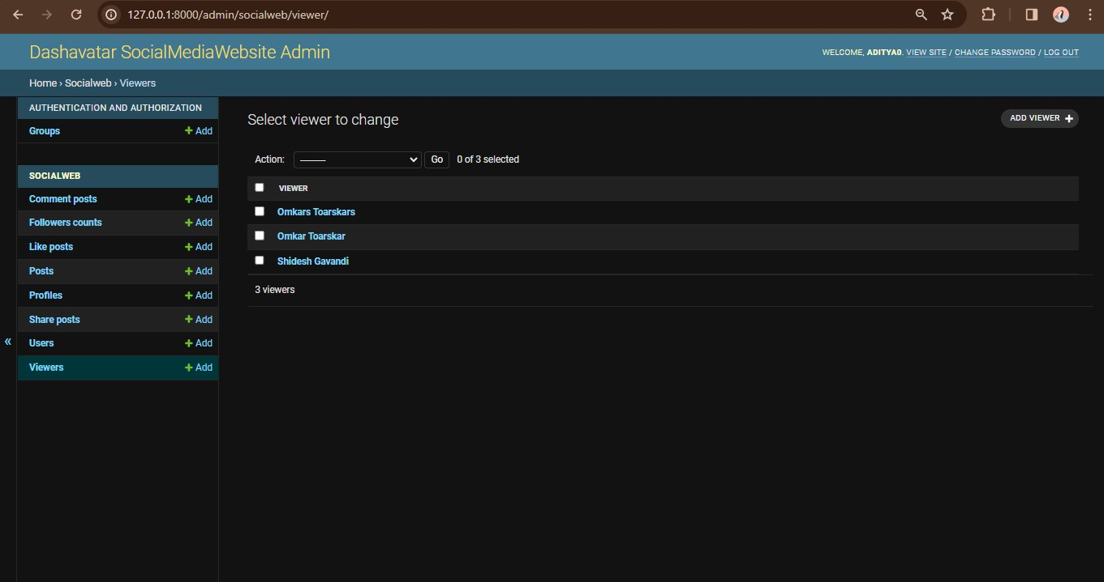

**Profile**

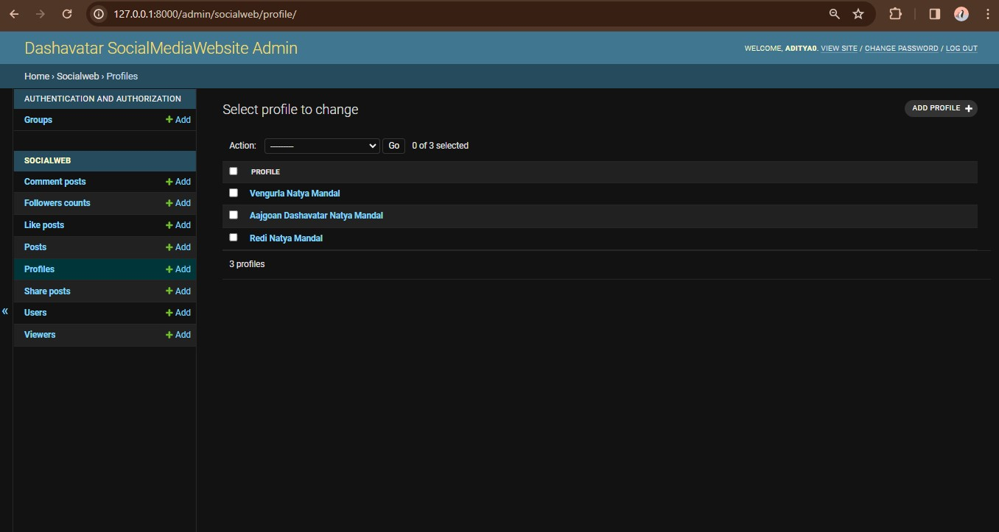

**Table Name: Followers**

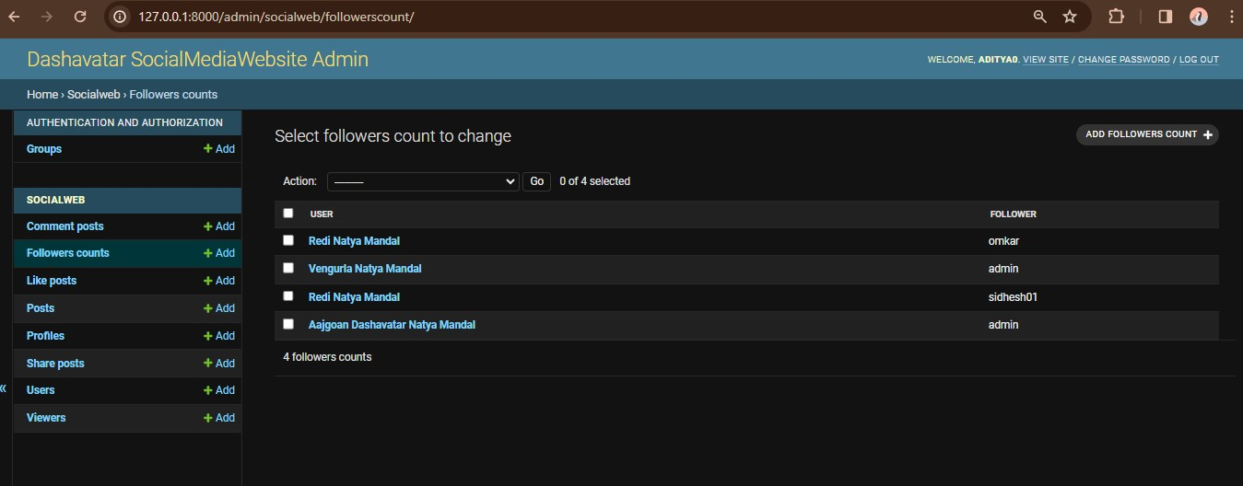

**Post**

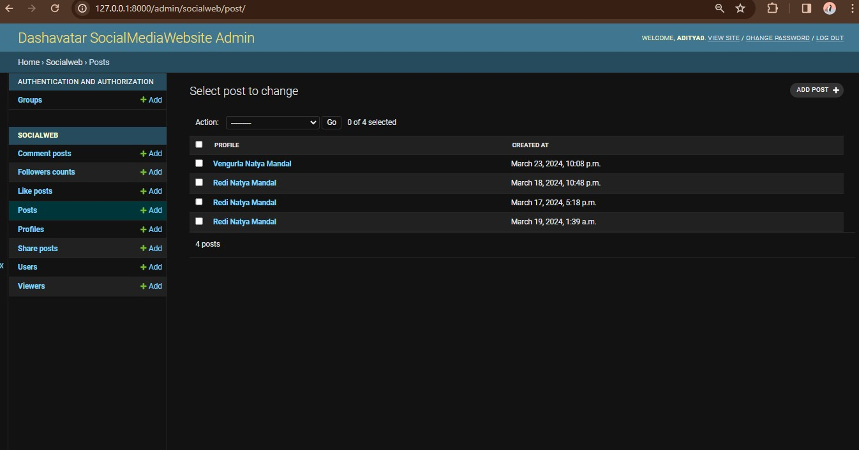

## 3.3 Entity Relationship Diagram

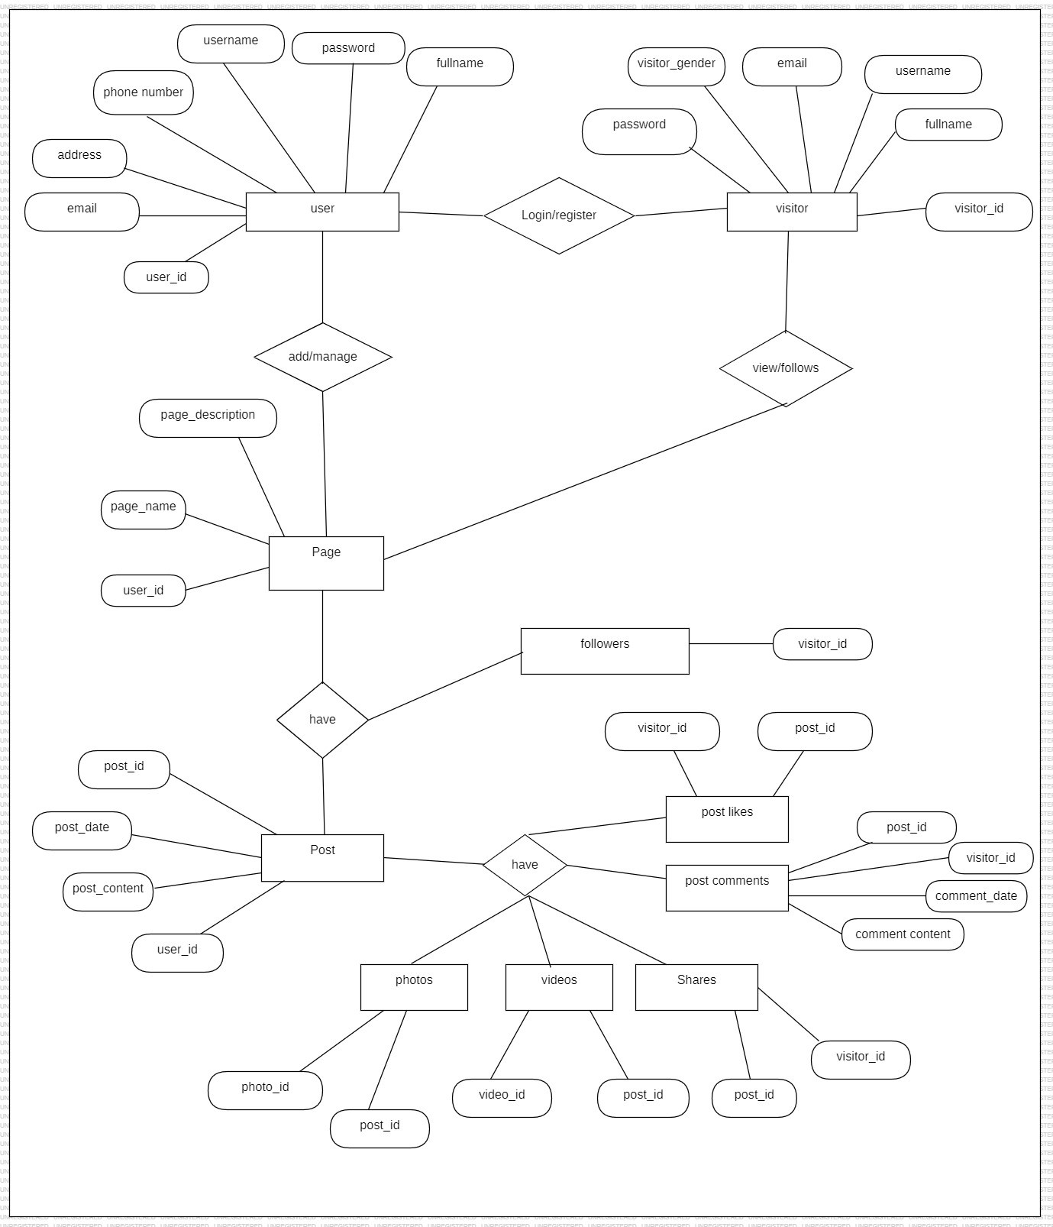

3.3 Entity Relationship Diagram

Entity relationship diagram is a specialized graphics that illustrates the interrelationship between in a database. In a er diagram uses symbol to represent the different type of information.

## 3.4 DFD/UML Diagrams

**Class Diagram**

**3.4.1**

Symbols used for Activity Diagram:

Class Diagram

3.4.1

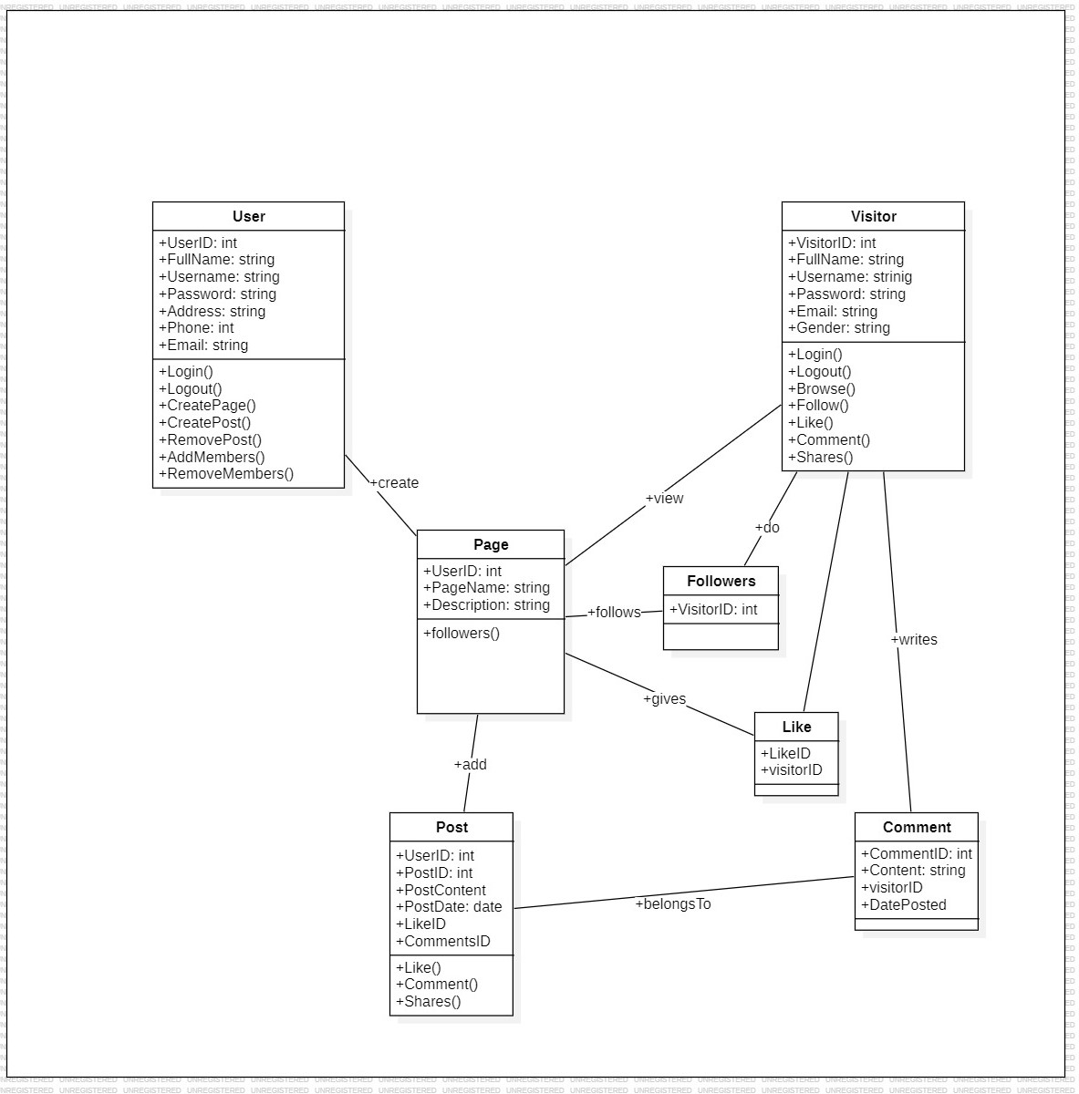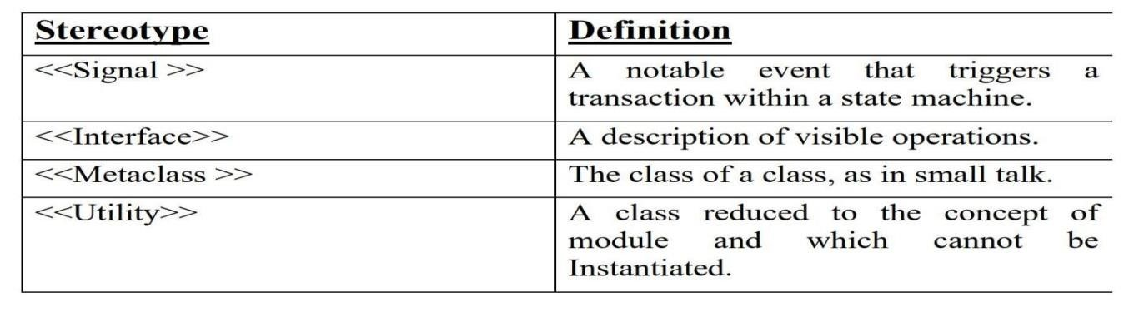

### 3.4.2 Activity Diagram

Symbols used for Activity Diagram:

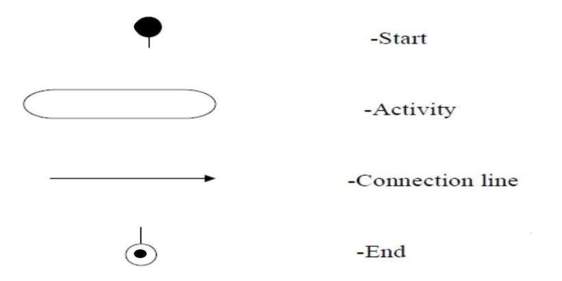

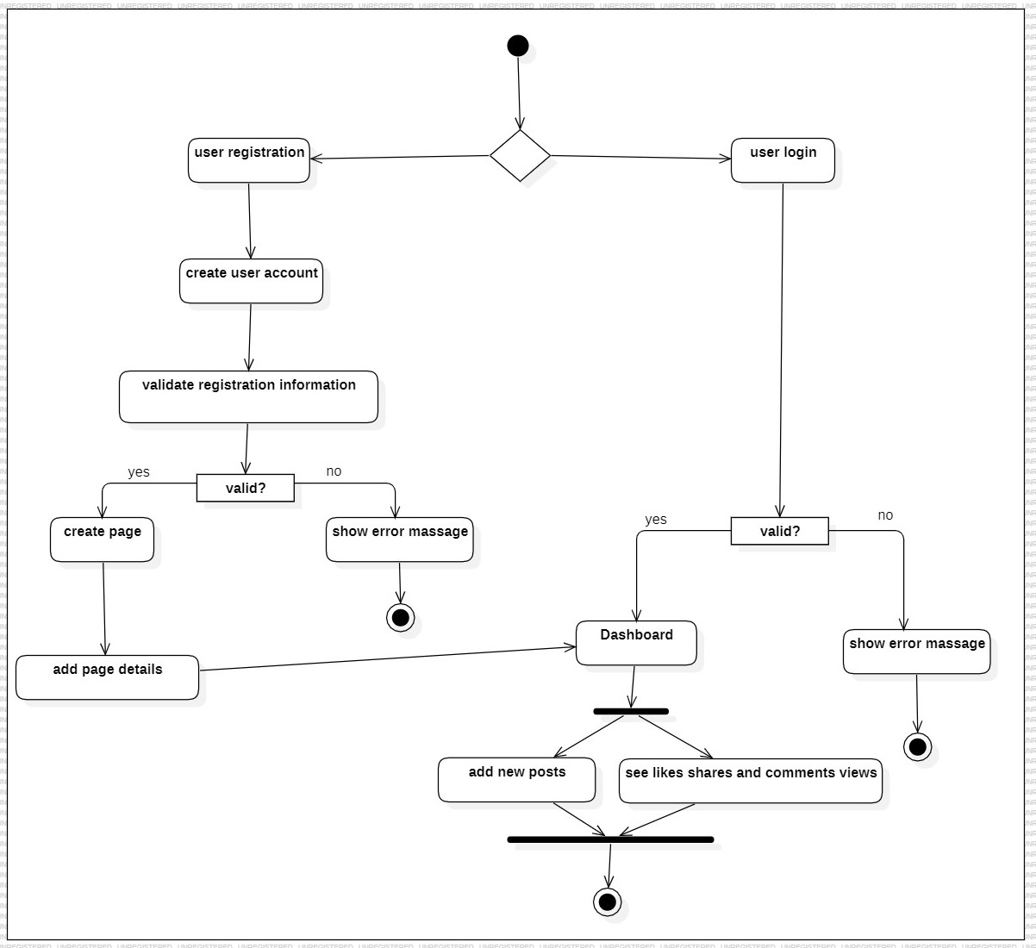

3.4.2.1 Activity Diagram For User

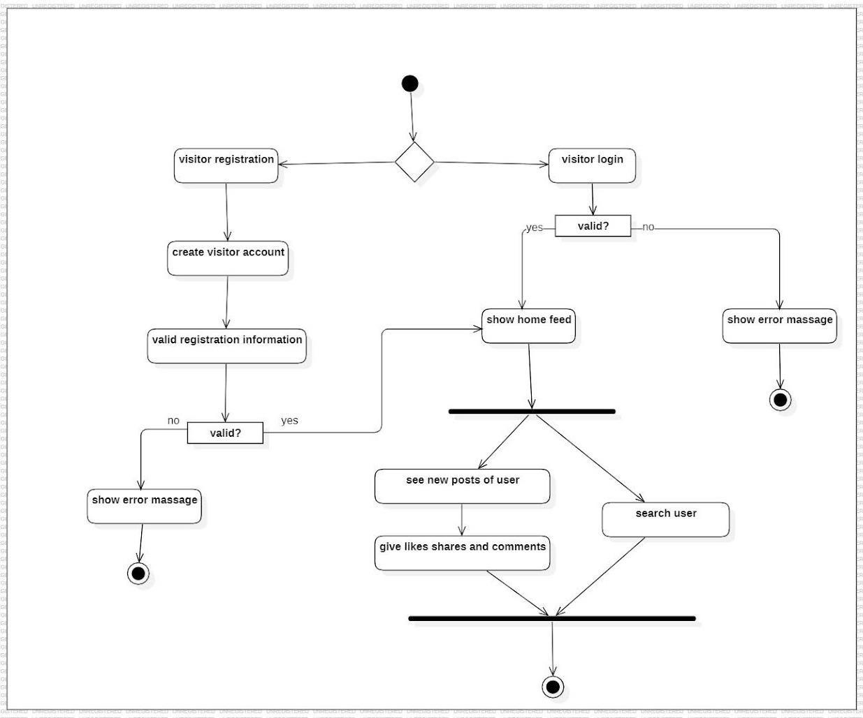 3.4.2.2 Activity Diagram For Visitor

### 3.4.3 Sequence Diagram

**Symbols Users:**

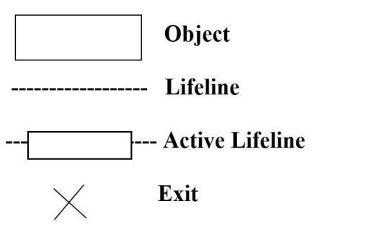

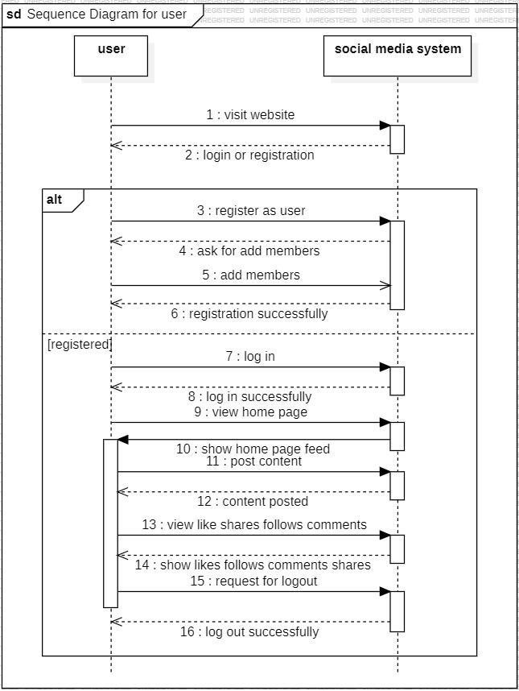 3.4.3.1 Sequence Diagram for User

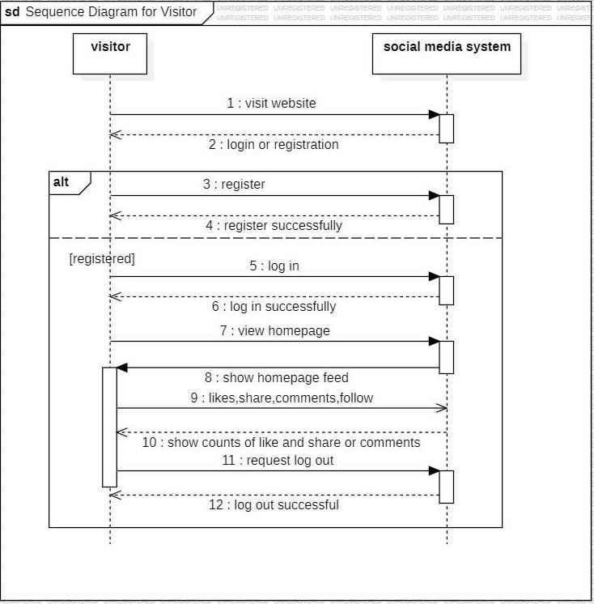 3.4.3.2 Sequence Diagram for Visitor

### 3.4.4 Usecase Diagram

Symbols used for use case diagram-



* Stick Person
* Use Case
* Connection Line
* Automation Boundary

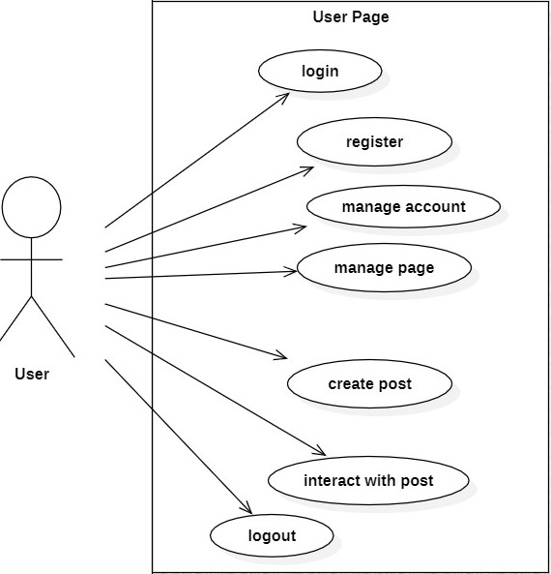

3.4.4.1 Usecase Diagram For User

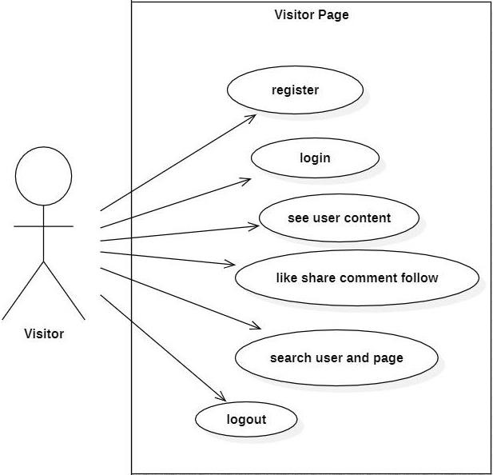

3.4.3.2Usecase Diagram For Visitor

# Chapter 4 Implementation and Testing

## 4.1 Code

Our coding approach for social media websites focuses on efficiency, scalability, and user experience. Through streamlined algorithms and optimized database structures, we ensure rapid data retrieval and seamless interactions. With modular design principles, we facilitate easy feature integration and continuous updates. Our code prioritizes security measures to safeguard user data and privacy. From frontend frameworks for dynamic interfaces to backend technologies for robust functionality, our approach ensures a smooth and engaging social media experience for all users.

## 4.2 Testing Approach

### 4.2.1 Unit Testing

* **User Model:** Test user creation, retrieval, and update functionalities. Ensure password hashing is working correctly.

* **Profile Model:** Test profile creation and update functionalities. Verify followers relationships are managed properly.

* **Viewer Model:** Viewer model ensures proper liking, sharing, following, and commenting on posts of the profile model.

* **Post Model:** Test post creation, retrieval, and update functionalities. Confirm likes, comments, and shares are associated correctly.

**4.2.2 Integration Testing:**

* Test the interaction between different components, such as user profiles, posts, and comments.

* Verify functionalities like liking a post creates an association with the user and updates the like count.

* Ensure commenting on a post creates a comment object linked to the post and author.

* Test sharing a post successfully adds it to the follower's feed with the original author's information.

## 4.3 Test Report

|  |  |  |  |
| --- | --- | --- | --- |
| **Test Type** | **Test Description** | **Pass/Fail** | **Comment** |
| **Functional Testing** | Upload Post, Likes, comments, follows, shares | Pass | All are working properly |
| **Performance Testing** | Test under heavy user load and big files upload | Pass | Handle big files and user load |
| **Security Testing** | Test For Login | Pass | No issue found |
| **Usability Testing** | Test user interface and experience | Pass | UI is easy to navigate and use |
| **Compatibility Testing** | Test on different devices and platforms | Pass | Website work properly on all devices and platforms |

# Chapter 5 Results and Discussions

## 5.1 Screenshots

## 5.1.1 User View

Login :

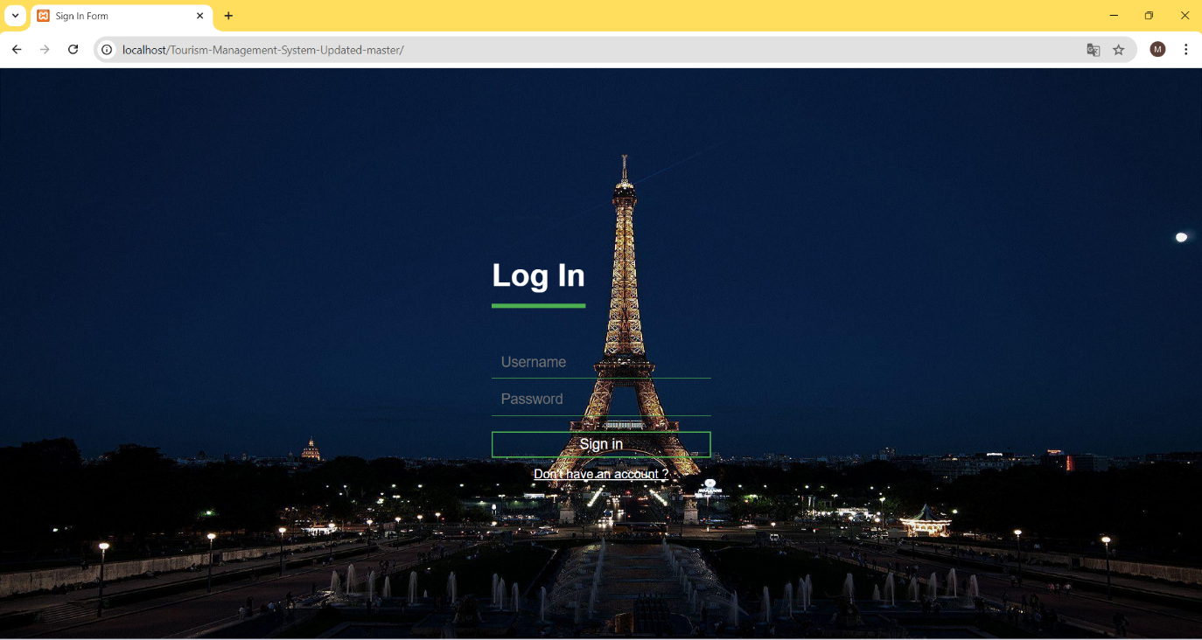

The user and admin can login from here.

Register:

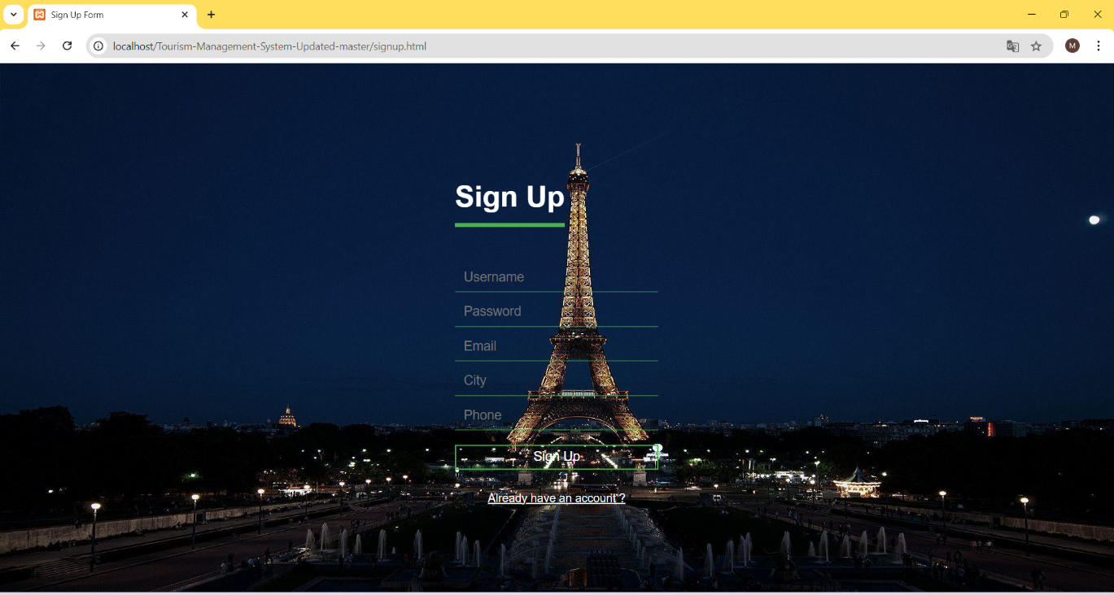

Registration form for user.

Home Page:

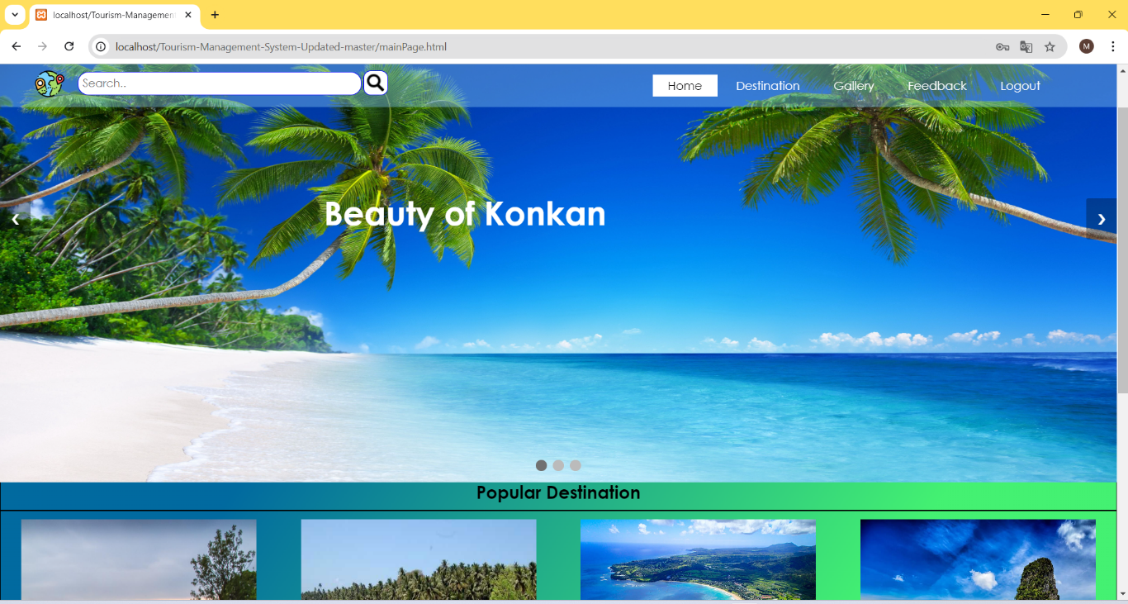

Home page of Tourism website: Here, user can view updates on recent posts and new places .

Destination:

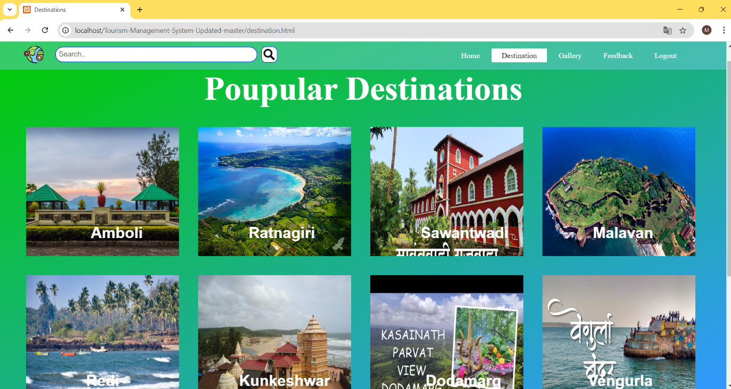

Destination page: Here, user can see multiple destination in konkan for traveling.

Gallery:

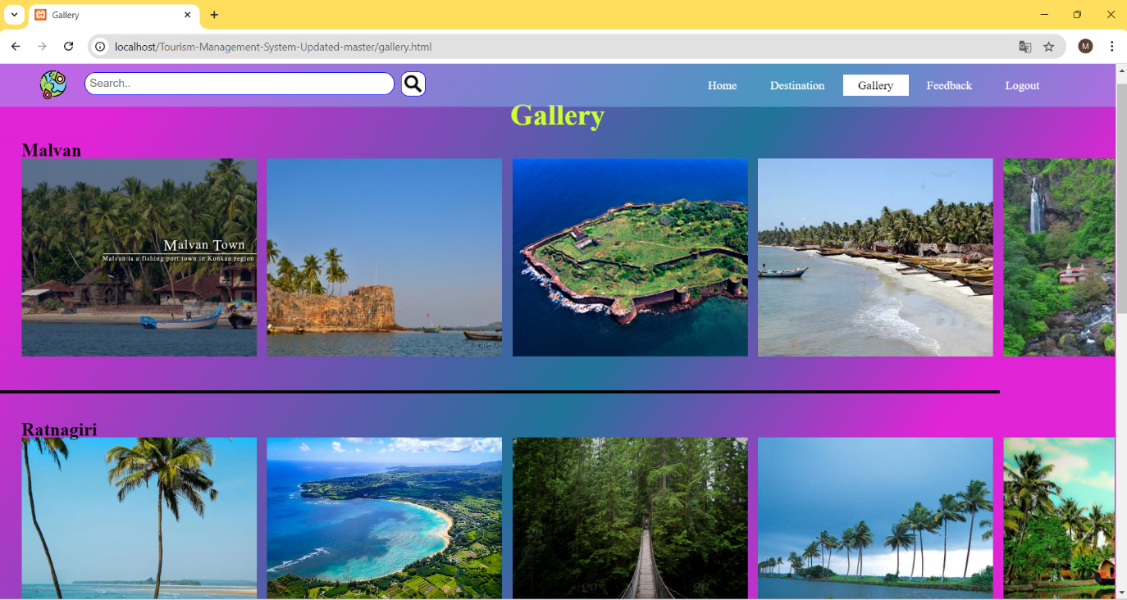

Gallery:Here, user can see konkan images (temple,water falls, fort, sunset point, beaches,etc.).

Place Information:

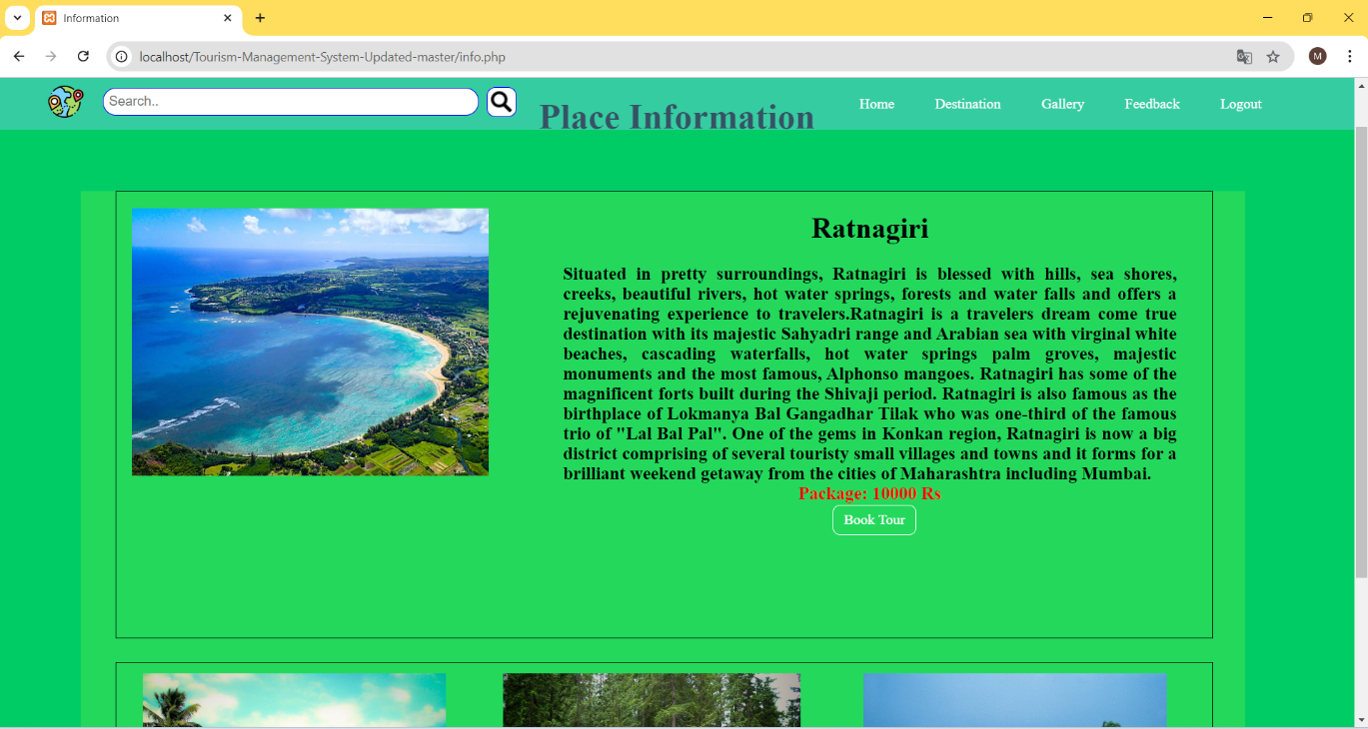

Place Information: Information about select your destination and those beautiful places.

Tour Booking:

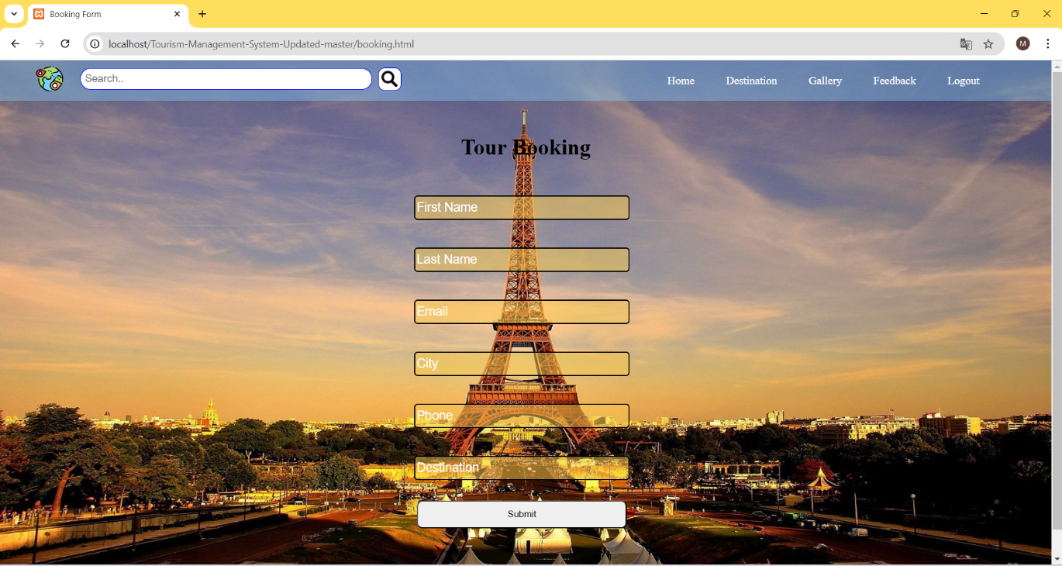

Tour Booking: here, user can book the tour package in select place.

Logout:

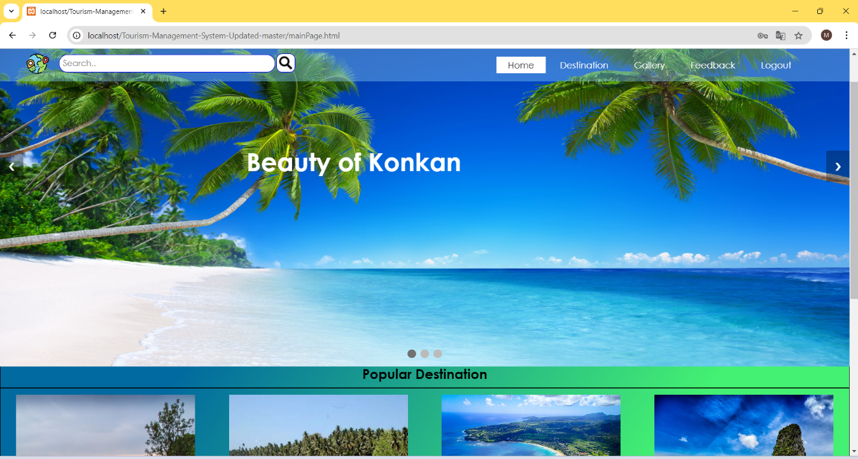

Logout: user logout the account.

## 5.1.2 Admin View

Admin Page:

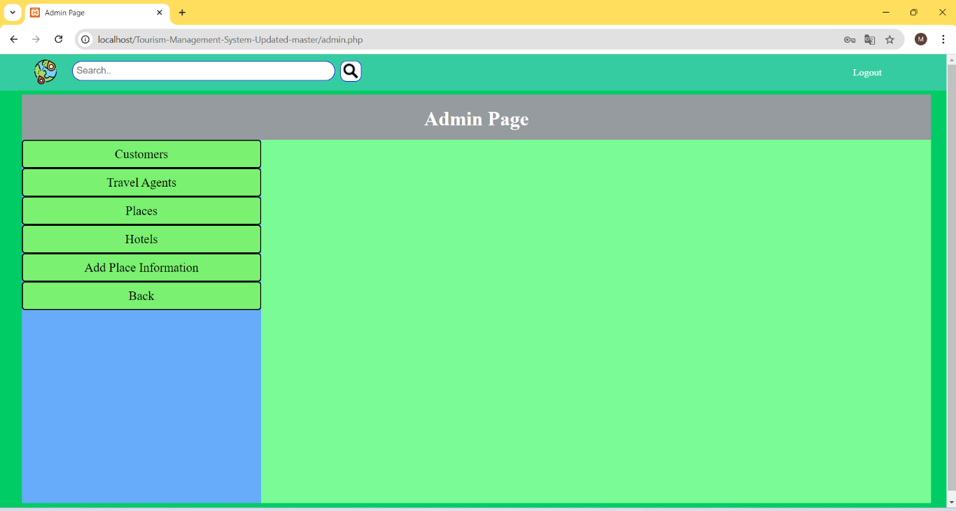

Admin page , control the admin for all website in this site.

Travel Agents:

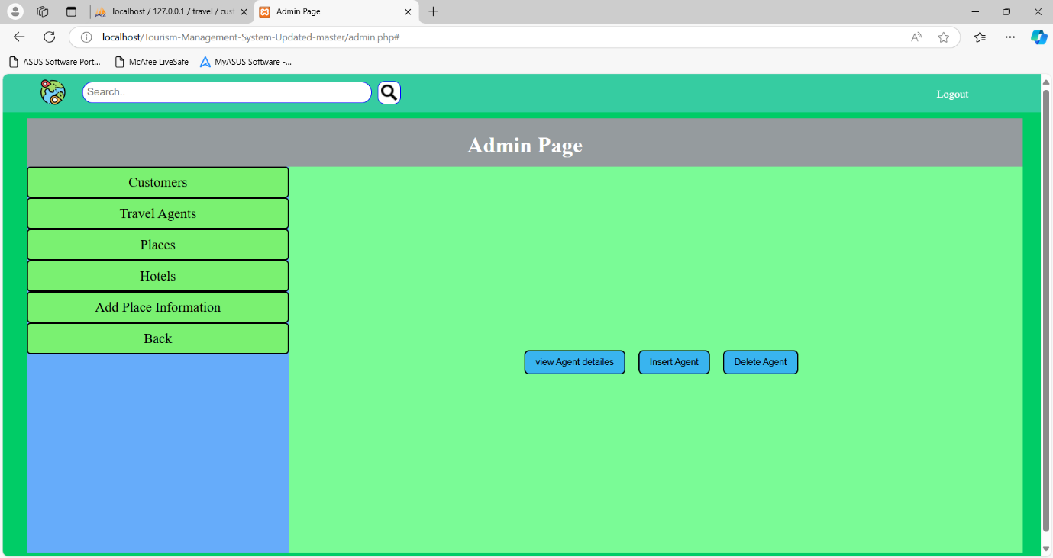

See the admin, travel agents information. Add the new agent and delete the agent all the operation perform in this page.

Places:

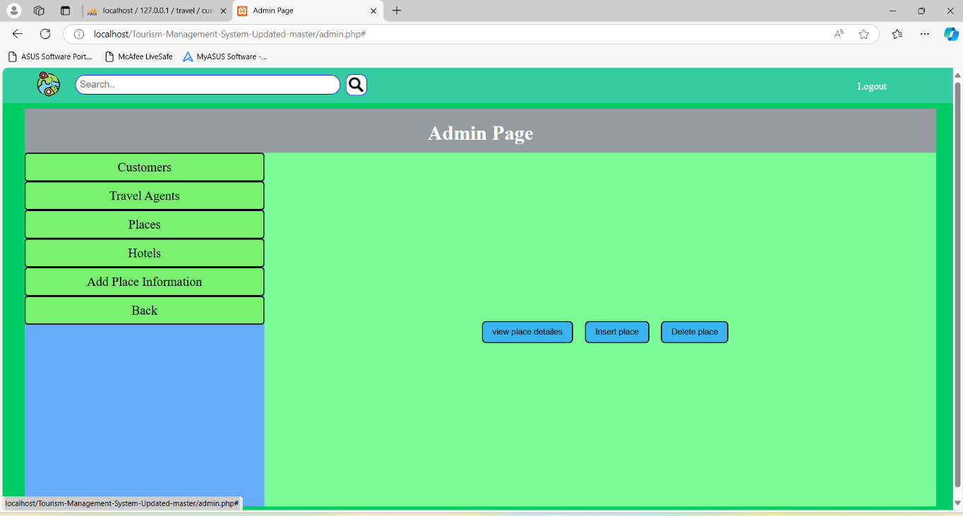

Admin can see places.(add,delete,view place.)

Hotels:

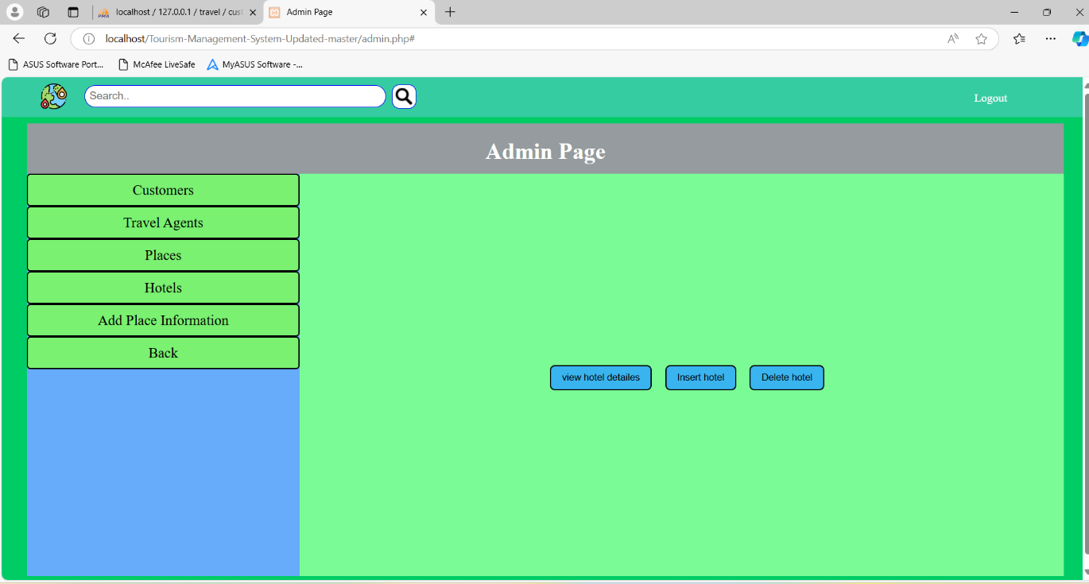

Add Places Information:

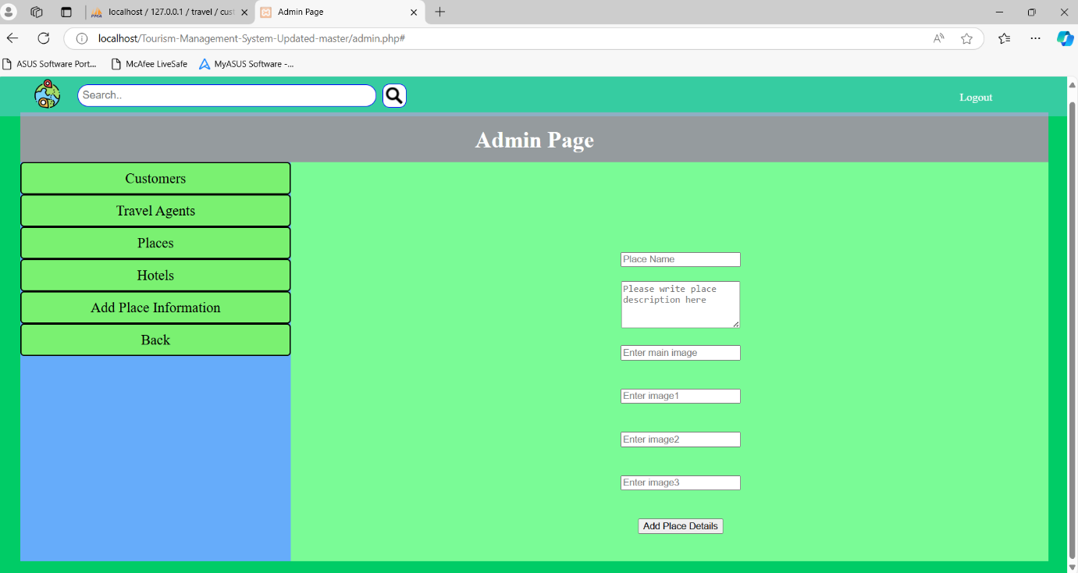

Admin add and update the places information to see the user

Customers :

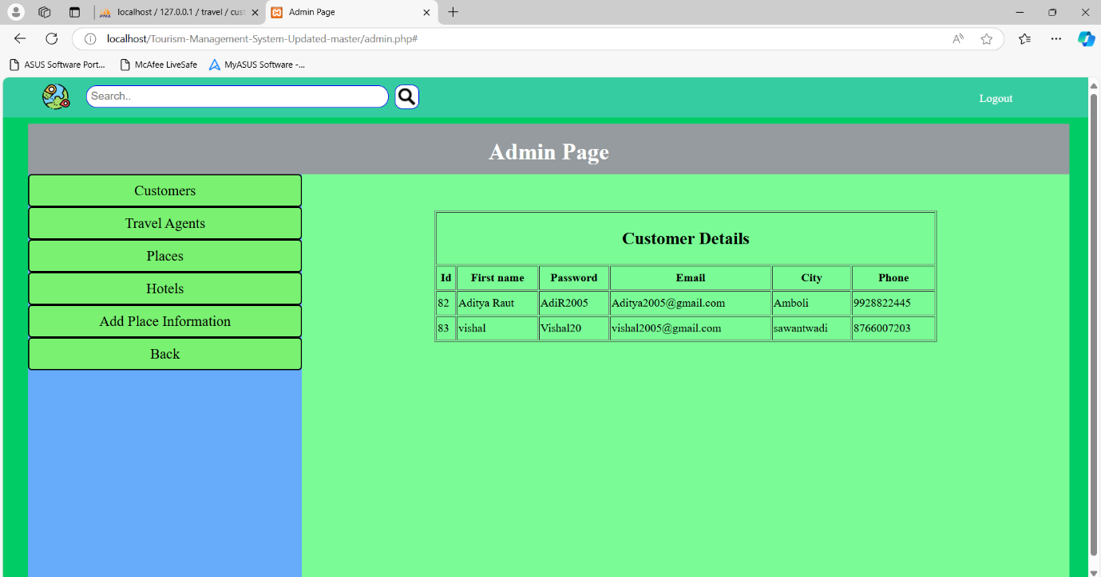

See the customer list and perform multiple operation(add, delete,etc.).

# Chapter 6 Conclusion and Future Work

## 6.1 Conclusion

This social media website, meticulously crafted using the robust Django framework, successfully establishes a dynamic platform for user interaction and content creation. It creates to two distinct user roles:

* **Profiles:** Empowered to express themselves by uploading engaging posts, fostering a thriving content ecosystem.

* **Viewers:** Actively participate by liking, commenting, and following Profiles, fostering a strong sense of community.

## 6.2 Future Work

* **Enhanced Profile Functionality:** Enhance the UI with new tools and implement a proper dashboard to display post impressions.

* **Messaging System:** Facilitate private communication between Profiles through direct messages or chat functionalities.

* **Advanced Features:** Explore options like broadcast creation, trending topics to further enhance engagement.

* **Deployment:** Choose a suitable hosting platform (e.g., Heroku, AWS, Google Cloud) to make your website accessible to the world.

# Chapter 7 References

[1]. [www.Enext.com](http://www.enext.com/)

[2]. [www.youtube.com](http://www.youtube.com/)

[3]. [www.w3School.com](http://www.w3school.com/)

[4]. [www.stackoverflow.com](http://www.stackoverflow.com/)

[5]. [www.figma.com](http://www.figma.com/)